

Practical Project
Assistive Disability Interaction System
By
Nada Mohamed Zainelaabdin Cs
Manar Abdelbaky Hassan Ai
Sara Mahmoud Abdelrahman Cs

Supervised by:
Dr. Ayman Hassanein
Co-Supervisor:
Eng. Mohamed Amer
Eng. Ahmed Abdelmonem

Egypt 2025

Table of Contents

Table of Contents

Table of Figures

Table of Figures

Abstract

Chapter One
"Introduction"

Chapter One
Introduction
1.1 Problem Statement:
Individuals with visual, hearing, or speech impairments face significant challenges in navigating and interacting with real-world environments safely and independently.
Existing systems typically focus on digital accessibility but do not provide real-time assistance in physical spaces.
Consequently, users encounter the following challenges:
Visually impaired users: Difficulty perceiving obstacles, pedestrians, or signs in the environment.
Hearing impaired users: Inability to detect auditory cues such as approaching vehicles, alarms, or verbal instructions.
Speech impaired users: Limited ability to communicate their intentions in real-time with others in their surroundings.
General safety risks: Lack of real-time guidance and environmental awareness increases the risk of accidents or miscommunication.
These limitations restrict independence, reduce mobility, and create barriers for full participation in daily life.

1.2 Proposed Solution:

The proposed system provides real-time, context-aware assistance for individuals with disabilities to interact safely and effectively with their surroundings.
Key features include:
Visual guidance for the visually impaired: Cameras and sensors detect obstacles, directional cues, and important environmental features, providing audio alerts and instructions such as “move forward,” “obstacle ahead,” or “turn left.”
Environmental awareness for hearing impaired users: Visual alerts, captions, or vibration notifications for events or sounds in the surroundings, such as approaching vehicles or alarms.
Communication support for speech impaired users: Interfaces that convert typed or gesture-based inputs into spoken messages, enabling real-time interaction with people nearby.
Multi-modal feedback: Combines audio, visual, and haptic feedback according to the user’s needs.
Mobility and independence enhancement: Provides real-time, actionable guidance to navigate safely in streets, public spaces, or crowded environments.

1.3 System Objectives:
1.3.1Primary Objectives:

Empower users with visual, hearing, and speech impairments to navigate and interact safely within their physical surroundings. Deliver instant, real-time alerts and guidance to help users avoid obstacles, hazards, and unsafe situations.
Enhance human-to-human interaction by providing adaptive communication tools suitable for different types of impairments.
Implement a multi-modal feedback system, including audio, visual, and haptic signals, tailored to each individual’s accessibility needs.
Foster greater independence, confidence, and safety for users during daily mobility and social activities.

1.3.2 Secondary Objectives:
Leverage computer vision and AI technologies to detect obstacles, recognize signs, and interpret environmental cues effectively.
Incorporate speech recognition and text-to-speech capabilities to facilitate real-time communication between users and their environment.
Ensure compatibility across multiple platforms to maximize usability.

1.4 Key Takeaways:
The system is designed to support individuals with visual, hearing, and speech impairments by providing real-time guidance, adaptive communication, and multi-modal feedback. It aims to enhance user independence, safety, and confidence in everyday interactions.

1.5 Technologies Used:
Git & GitHub for version control

Chapter Two
"Design and Methodology"

Chapter Two
Design and Methodology
2.1 Requirements and Analysis
2.1.1 User requirements
UR1: Users with disabilities shall interact with the system using accessible methods.
UR2: Visually impaired users shall receive audio-based interaction.
UR3: Hearing-impaired users shall receive text and visual interaction.
UR4: Speech-impaired users shall be able to use touch or typing to communicate.
UR5: All users shall be able to adjust accessibility settings according to their needs.
UR6: Users shall be able to access system features without requiring special training.

2.1.2 Software requirements:
2.1.2.1 Functional requirements: What the system must do.
1-User Accounts & Login: Users can create accounts, log in securely, and recover passwords if needed.
2-User Profile (Disability Information): Users can save their disability type, communication preferences, and other personal details.
3-Accessible Communication: Users can send text messages, voice messages, and make video calls.
4-Assistive Communication Tools: Real-time captions, speech-to-text, and text-to-speech for better communication.
5-Sign-Language Support: Video option for users who use sign language.
6-Emergency Contact: One-tap SOS button sends alerts and location to caregivers or authorities.
7-Contacts & Social Connection: Users can add friends, family, or caregivers and communicate easily.
8-Notifications: Alerts for new messages, requests, or emergency responses.
9-Accessibility Settings: Users can adjust text size, colors, audio settings, and use a simplified interface.

2.1.2.2 Non-functional requirements: Quality standards the system must follow.
1-Accessibility: Must follow WCAG 2.1 guidelines to ensure all users can access and use the system effectively.
2-Performance: Messages should load instantly, and video/audio calls should run smoothly with minimal latency.
3-Security: Data must be encrypted, login secured, and privacy protected.
4-Reliability: System should be available 24/7 with minimal downtime.
5-Usability: Interface must be simple, intuitive, and easy to navigate for all users.
6-Scalability: Must support many users communicating simultaneously without slowing down.
7-Compatibility: Works on mobile phones (iOS & Android), tablets, and desktop computers.
8-Localization: Supports multiple languages, including Arabic and English, with proper layout for right-to-left text.
9-Backup & Recovery: Regular data backup and recovery plan to prevent data loss.

2.1.3 Software Process Model:
The system design model that we use is Incremental model according to system needs and our team suggestions
2.1.3.1 What is Incremental Model?
The Incremental Model is a software development approach where the system is built and delivered
in small, functional parts called increments. Each increment adds more features to the system until
the complete system is delivered. Early increments may contain core functionality, and subsequent
increments enhance the system with additional features.
2.1.3.1 Phases of Incremental Model
- Requirement
- Design
- Testing phases
- Implementation phase

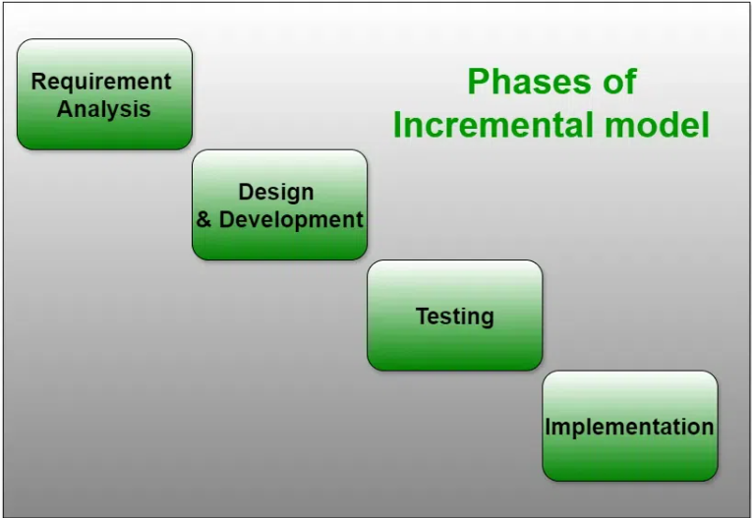
2.1.3.3 Advantages of Incremental Model
- Early delivery of core functionality allows users to start using the system sooner
- It is easier to manage risk and make changes in later increments.
- Allows feedback from users after each increment to improve subsequent parts.
2.1.3.4 Disadvantages of Incremental Model
- Incomplete systems in early increments may not provide full functionality to users.
- Requires careful planning to ensure all increments integrate smoothly.
- Can become costly if initial design is not flexible enough for changes.
2.2 System Models
2.2.1 Interaction perspective
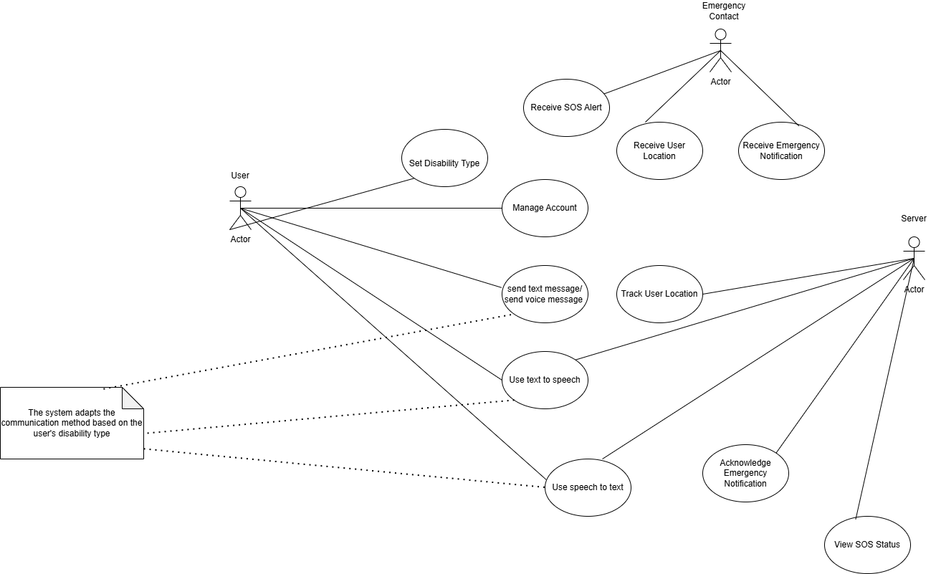
2.2.1.1 Use Case Diagram

2.2.1.2 Sequence Diagram

2.2.2 Data Flow Diagram
2.2.2.1 Context Diagram

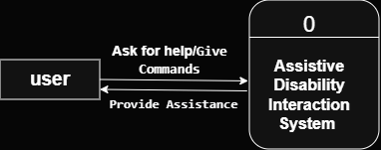

2.2.2.2 DFD (Level 1)

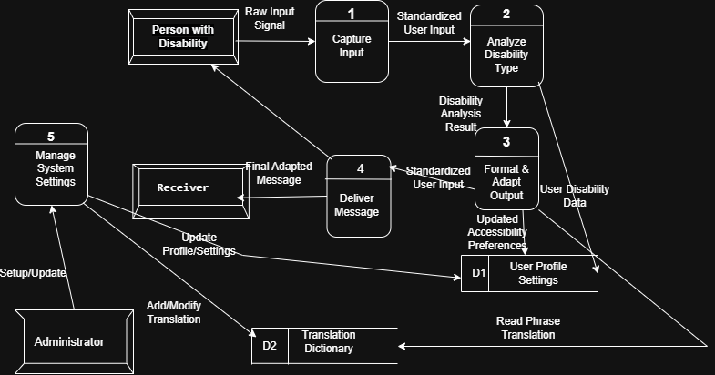

2.2.2.3 DFD (Level 2)

2.2.3 Activity Diagram

2.2.4 Structural perspective
2.2.4.1 Class Diagram

2.2.5 Entity Relationship Diagram (ERD)

References

References

